PREDICTIVE MAINTENANCE OF INDUSTRIAL MOTORS

Internship with Smart Bridge

Keerthana J

17BEC1033



Predictive Maintenance of Industrial Motors

Industrial motors are prone to wear and tear or some component going wrong that could lead to the failure of the whole system put in place. This project is an attempt to identify potential mishaps to avoid it leading to bigger problems. The factors we will be measuring include Temperature, Humidity, Vibration and Amount of Current passing through. The sensor measurements will be sent to the cloud and is any factor was to go off limits, the motor receive a shutdown trigger where it will turn off by itself to prevent any further problems.

ABSTRACT

Be it in an engine of a car or in huge purification plants, industrial motors are prevalent in control systems in almost all realms of engineering. Industrial motors have areas designated to measure the mentioned parameters instead of manually measuring these parameters, sensors will be placed at the respective positions to take the readings and send the data to the cloud. In this case, we are using the lite version of the IBM Cloud as it is very efficient and easy to use. This data is monitored by sending it through an anomaly monitoring algorithm with the help of the Node-Red Application. From there. It is sent in JSON format to MIT APP Inventor which helps in the creation of an app that can be used to monitor the levels as well. The Motor can even be switched ON and OFF remotely using the MIT App. This way the motor can be monitored anytime, anywhere and smooth functioning can be guaranteed.

INTRODUCTION

The main domain we will be using is the Internet of Things (IoT). Connecting all kinds of devices to the cloud is said to be the torchbearer of the fourth industrial revolution. Sensors and Actuators help in collecting a whole repository of data but where does all this data go. The Cloud is a simple and efficient way of sharing digital space for companies to use without the necessity to invest in heavy duty equipment which are a huge commitment such as server systems. The cloud enables companies to use only how much is necessary and make the most of it. Another very interesting feature of the cloud is that it can be used to maintain a plethora of devices. For example, imagine a device being developed and sold to hundreds of people. There is a small glitch in the device and a change has to be made. Now one would have to repair each and every device. With the device’s program uploaded to a cloud, the glitch can be fixed online and it makes the process so much simpler.

LITERATURE SURVEY

Arduino is very popular for all kinds of projects these days. It is an open-source platform with very simple and foolproof hardware. The Arduino Uno board also supports over-the-air (OTA) programming of Arduino sketches and or firmware. Hence, it would be a good pick for this IoT project as it can seamlessly connect to the cloud.

It is predicted that by the year 2025 there will be an approximate of 41.6 billion devices according to IDC. Hence, finding solutions for everyday problems related to IoT will help predict potential industrial projects.

Internet of Things allows for accurate real-time analysis technology and an in-memory database. This leads to higher access speed compared to hard disk drives. Therefore, if we get data of temperature, humidity, vibration and current, we will be able to send a technician to fix it when any one of the factors go out of limits. This way we can ensure business objectives can be met.

Even a delay of 30 minutes could lead to a huge loss for a company as production may be faulty due to motor failure.

BLOCK DIAGRAM

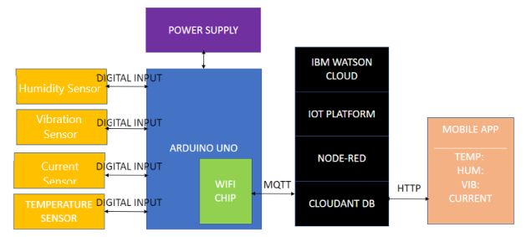

HARDWARE DESIGN

1. Temperature Sensor and Humidity Sensor (**MCP9802A5T-M/OT)**



Double up your sensor needs by using this MCP9802A5T-M/OT temperature and humidity sensor from Microchip Technology. It has a digital output. This part has a resolution of 12(Max) bit. This device has a minimum operating supply voltage of 2.7 V and a maximum of 5.5 V. This part has a minimum operating temperature of -55 °C and a maximum of 125 °C. The temperature of the motor can help us determine if the motor is working well or if its is overheating, etc.

1. **Vibration Sensor with Digital Output for Arduino & Raspberry Pi**

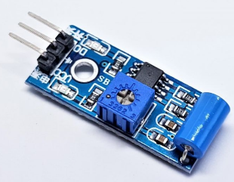

This sensor is useful to measure vibrations and motion. These sensors offer high sensitivity non-directional vibration and motion detection. Inside there is a soft spring coiled around a long metal pin. When the switch is moved, the spring touches the center pole to make contact. The sensor has an onboard potentiometer which can be used set the desired vibration threshold as per individual application, when the vibration detected by the module cross the set threshold, the output pin goes high. When the vibration detected by the module is below the set threshold, the output goes low.  
  
This module works on 5V and can be used with Arduino, Raspberry Pi and other microcontrollers. Comes with a simple to use and interface digital output. It comes with a mounting hole, which can be used to mount the sensor onto a fixed platform.

This module is great to detect motion, vibration, sense machine health and service condition (by sensing the vibrations), this way we can identify any noise coming from the motor which usually leads to malfunction.

1. Current Sensor

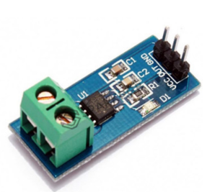

The ACS712 outputs an analog voltage output signal that varies linearly with sensed current. The device requires 5VDC for VCC and a couple of filter capacitors. Please keep in mind that though the ACS712 is rated for 2.1kV isolation, the PCB it is on is not designed for that type of voltage. Please keep that in mind if you are using this breakout in high voltage applications.

1. Arduino Uno Rev3

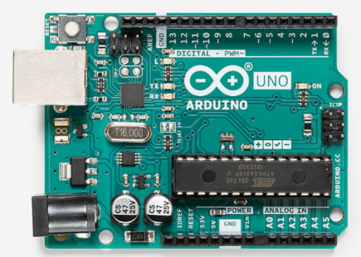

**Arduino Uno** is a microcontroller board based on the ATmega328P. It has 14 digital input/output pins (of which 6 can be used as PWM outputs), 6 analog inputs, a 16 MHz ceramic resonator (CSTCE16M0V53-R0), a USB connection, a power jack, an ICSP header and a reset button. It contains everything needed to support the microcontroller; it simply has to be connected to a computer with a USB cable or powered with a AC-to-DC adapter or battery to get started

We connect the respective sensors to the GPIO pins of the Arduino and set up serial communication. The sensor values that are obtained this way can be monitored to identify any anomalies. The actuation is the shutdown trigger that is activated once any one of the components goes out of limits.

Software Design

CONNECTING TO THE IBM CLOUD PLATFORM

The program is shown below and the temperature, humidity, vibration and current sensor values are displayed.

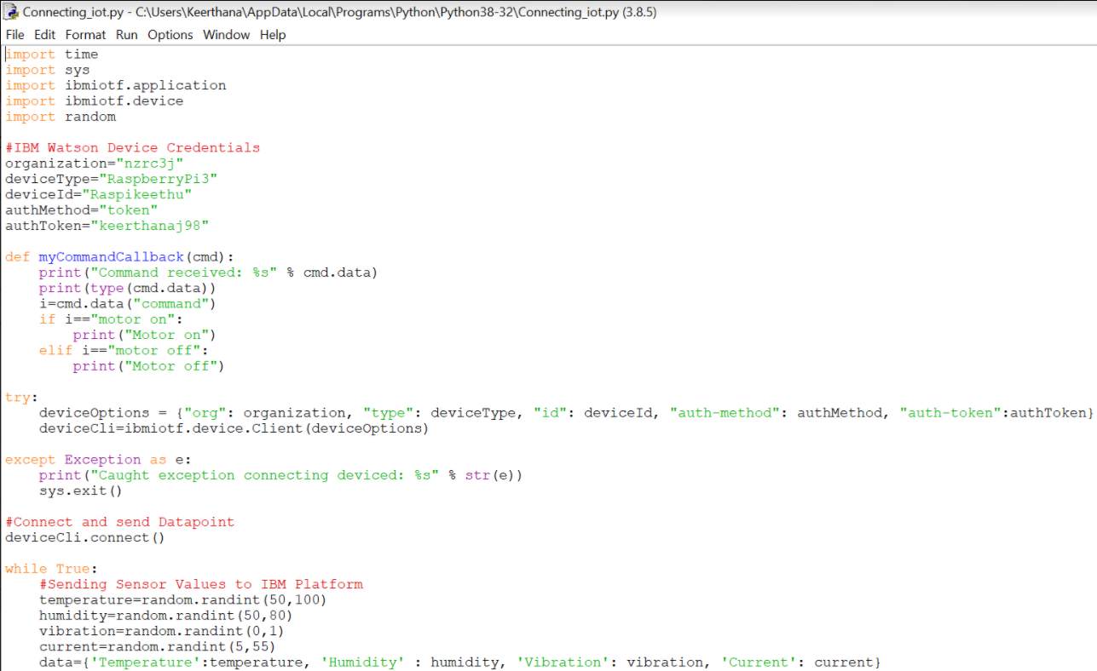

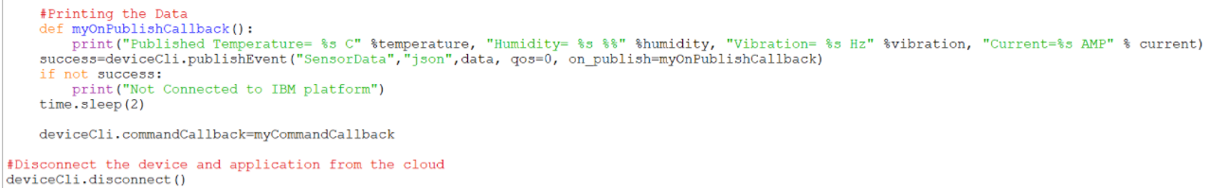

The output from this program is:

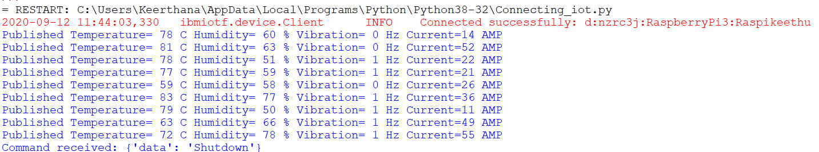

IBM CLOUD

The IBM Cloud provides a full-stack, public cloud platform with a variety of products in the catalog, including compute, storage, and networking options. There are various services available in the catalog in which we used the IoT platform, the node-red application and the cloudant db.

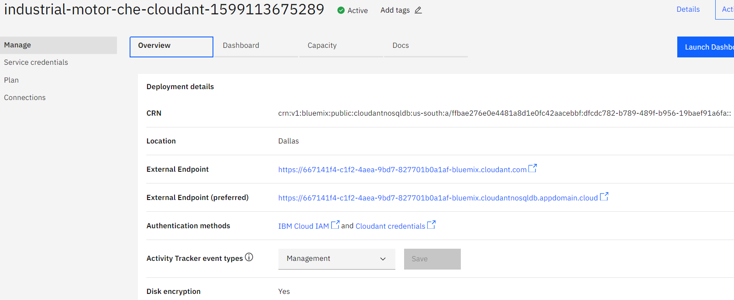

NODE-RED APPLICATION

Node-RED is a programming tool for wiring together hardware devices, APIs and online services. Primarily, it is a visual tool designed for the Internet of Things, but it can also be used for other applications to very quickly assemble flows of various services.

Designed and built by IBM, Node-RED is a free, open source logic engine that allows programmers of any level to interconnect physical I/O, cloud-based systems, databases, and API's. Node Red is very helpful in our case as it helps to organize a website based on our needs and it makes the process simple as well.

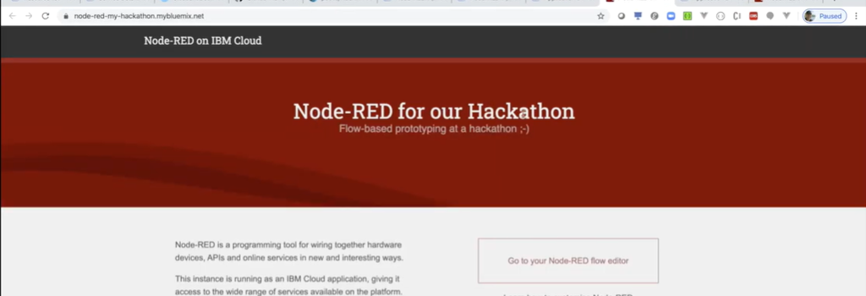

The overview of the wiring of our hardware devices can be seen in the image below.

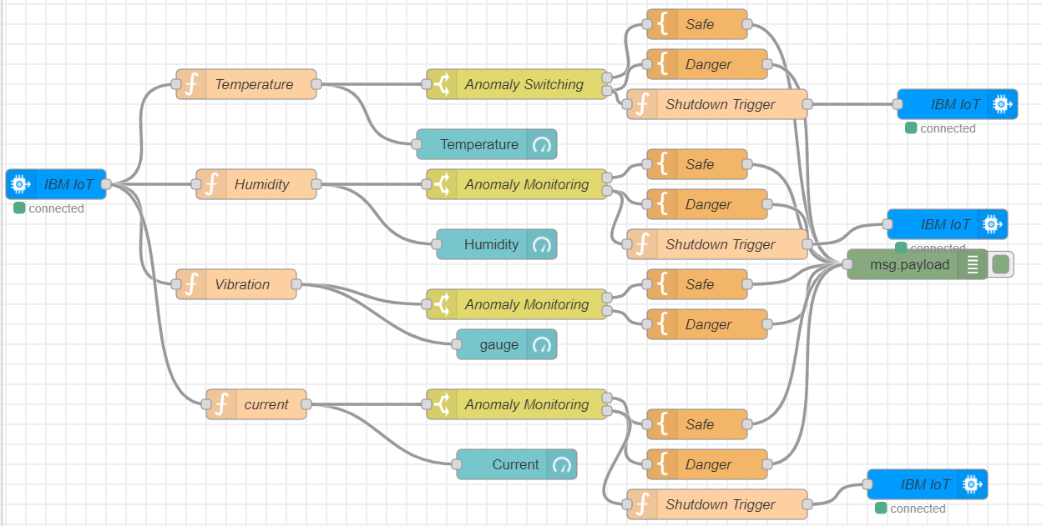

From the collective update from the sensor we isolate each parameter into Temperature, Humidity, Vibration and current so that we would be able to monitor the limits of each component. This monitoring is done in the Anomaly Monitoring block in which the threshold values for each component are set. If the values are within the acceptable range, they go to the ‘Safe’ block and send out the message that it is within limits. However, if the value goes beyond it goes through the ‘Danger’ block and sends an alert message as an output. It also goes through the ‘Shutdown Trigger’ function which immediately shuts down the motor and warns so that immediate action can be taken ensuring the whole process is not affected.

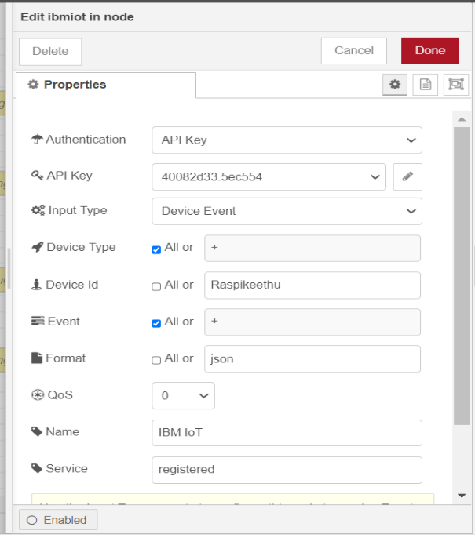

The sensor values are sent to the node-red application using a MQTT client. The Message Queuing Telemetry Transport is a lightweight, publish-subscribe network protocol that transports messages between devices. It is the most apt protocol for the Internet Of Things. As shown in the image above, filling in the API key, Input Type and Device Id, we can establish this connection.

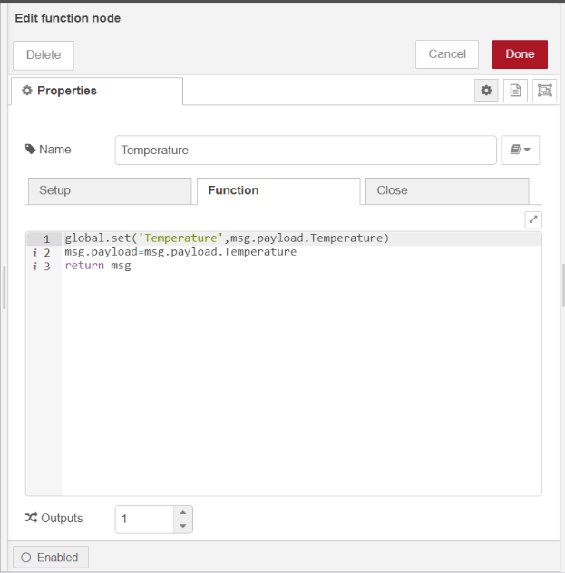

For each of the component functions, we set the message payload to print the temperature, humidity, vibration, and current value like shown for the temperature example above. We set it as a global variable to access it for the http client for the app.

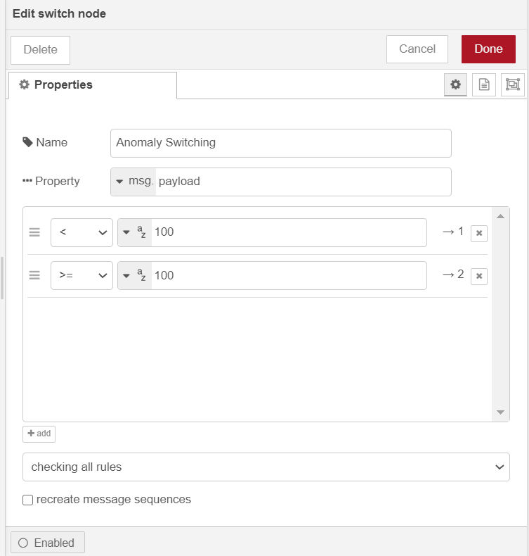

In the Anomaly switching block, we set the threshold values. For the temperature example above, we keep the maximum temperature attainable by the motor to 100 after which the maintainer will get the warning for faulty motor. The same way the thresholds are set for humidity at 80, for vibration when it reaches 1, for current at 55.

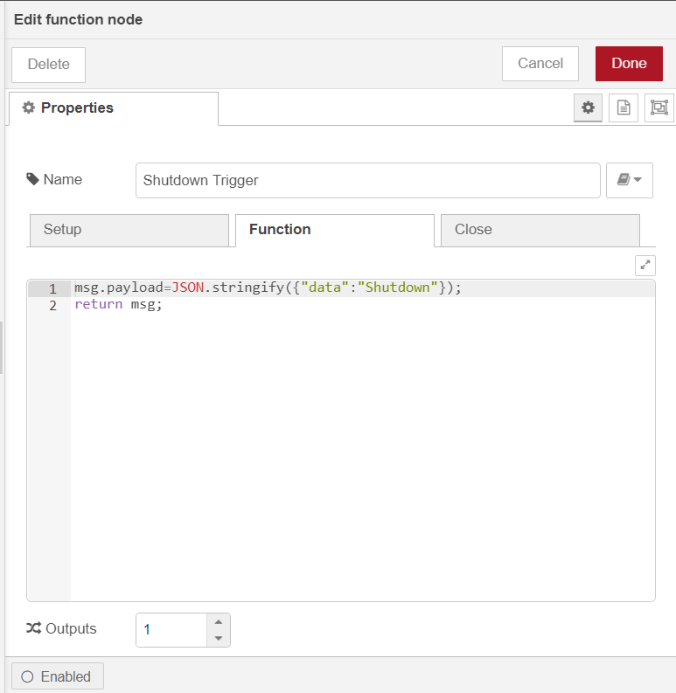

The payload for the shutdown trigger is shown above. This message is printed to indicate that the motor has initiated shutdown.

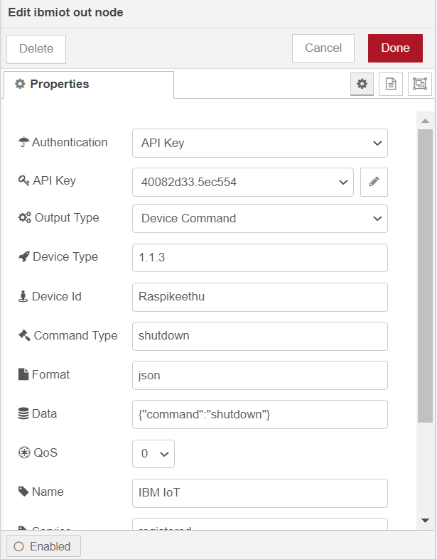

The shutdown has to be communicated to the motor, hence, the IBM out node is used, specifying the same API key, Device Type and Device Id as before.

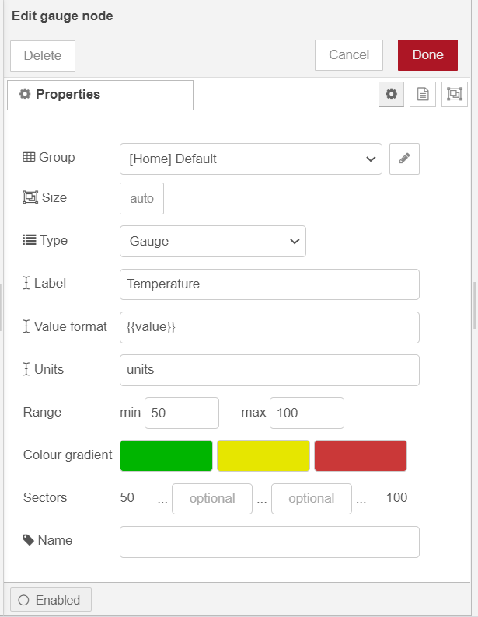

We need to set a way to visualize this data. There are plenty of ways to display the sensor values. For our values, we will be using the gauge to display as it is a simple yet effective way to know which range the temperature falls into.

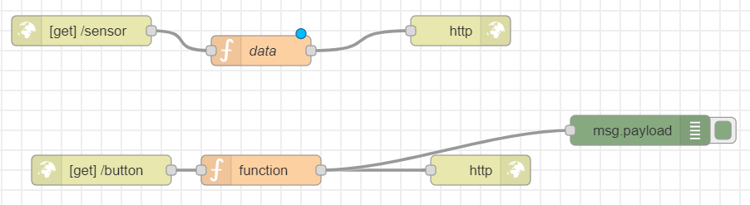

After the above setup is done, we get the values using the global variables in the data function as the message payload as shown below.

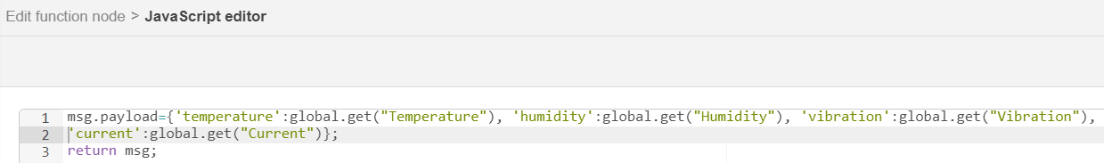

The data is communicated in the json which we can obtain by adding /sensor to the url.

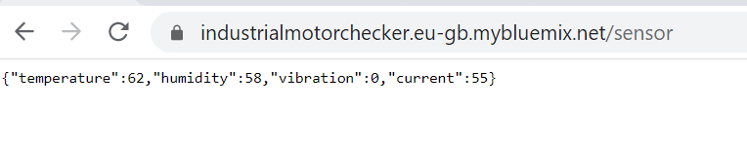

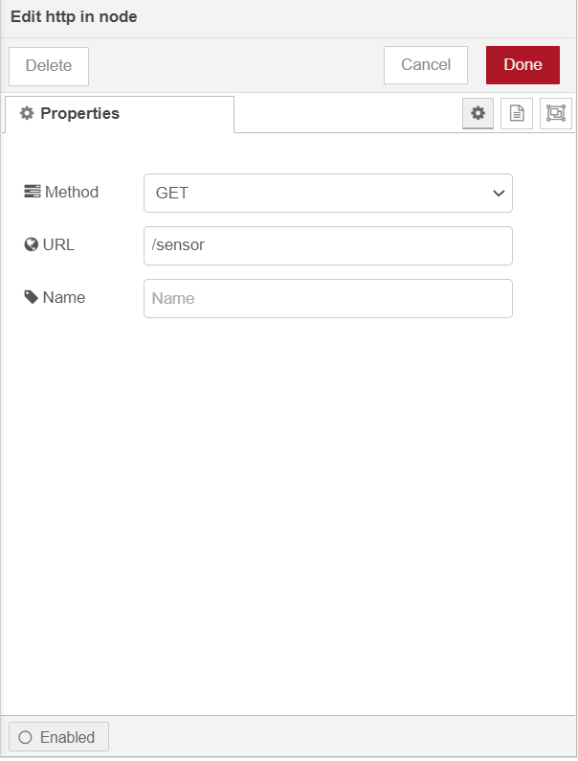

To be able to see the respective gauged and switches adding /ui to the end of the url brings us to the page where we can visualize the data.

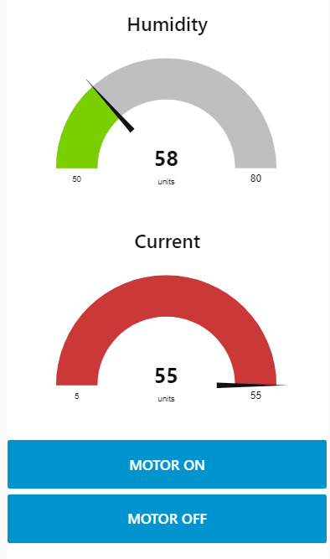

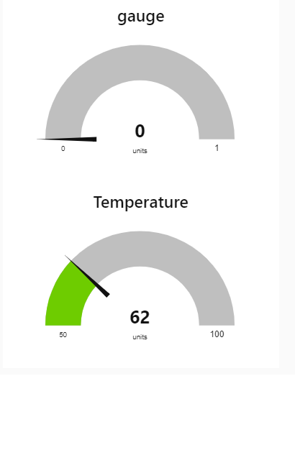

Next, we are configuring the buttons to turn on and off when required. To do that , we allow the commands to be controlled by the MIT App, where the message will be received from the app to the application using the web application and it will be turned off using a http client.

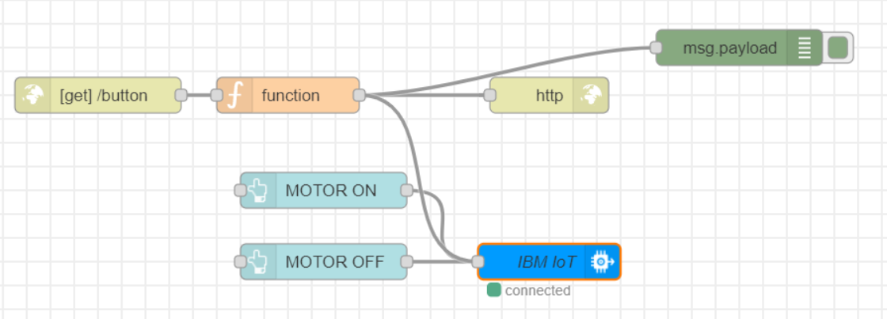

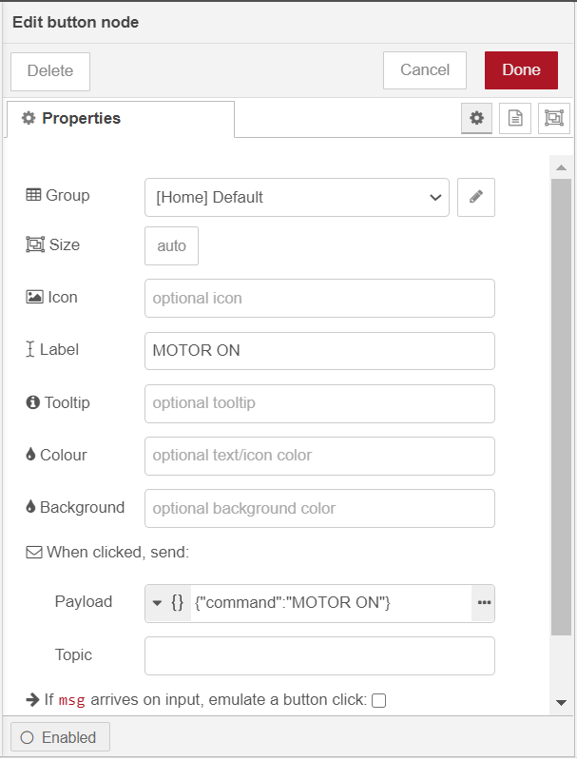

And the command is received and can be accessed by adding /button after the url as shown below.

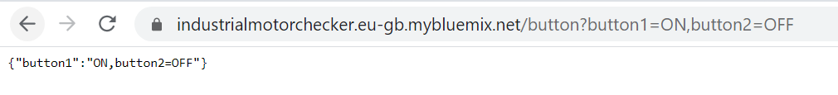

This is coordinated with the MIT app that will be explained further in the report.

IBM WATSON IOT PLATFORM

The IBM Watson IOT platform gives a space where one can setup and manage all the connected devices. Hence, this space can be used to manage the temperature and humidity sensor, the vibration sensor, and the current sensor.

After specifying the region and launching the platform, we are brought to the whole range of settings available. Where we can specify who is authorized to manage the devices, the level of security we want to maintain, etc.

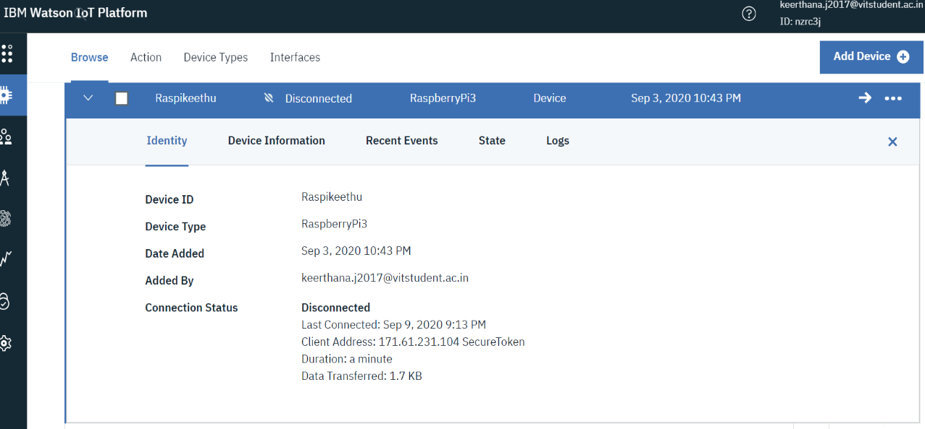

MIT APP INVENTOR

The MIT App Inventor initially created by Google makes creating a web application integrated environment.

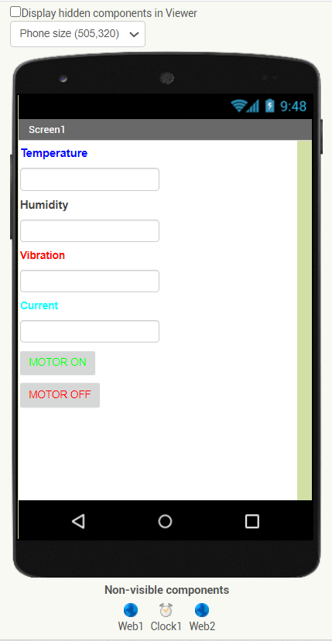

We can set up what we want our app to look like. Here, I set up the Temperature with the box to display the value and the same for humidity, vibration and current. I also added buttons for turning the motor on and off which will be controlled with the help of the http client as mentioned above.

This is the picture of the fabric behind the app. There are 2 web components: one to receive the sensor value and the other to send the command for turning on and off the motor. The clock is set using the first block. We are getting each component value in the form of json text and using the getresponseContent we display the values in the app.

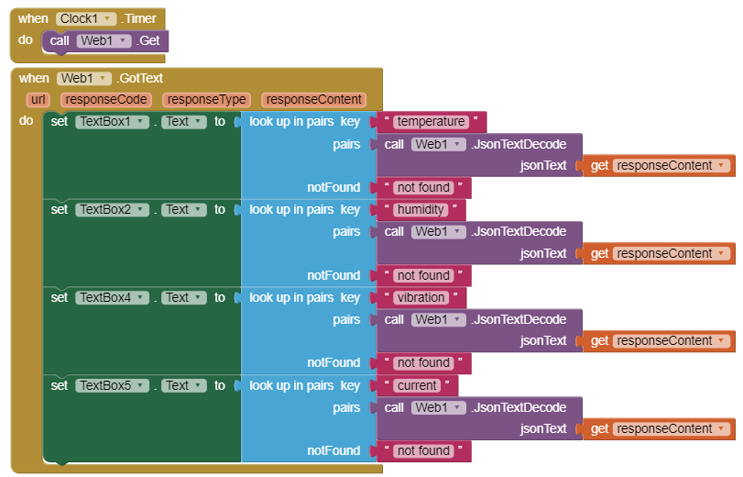

To allow the buttons to be controlled from the app we add the blocks below

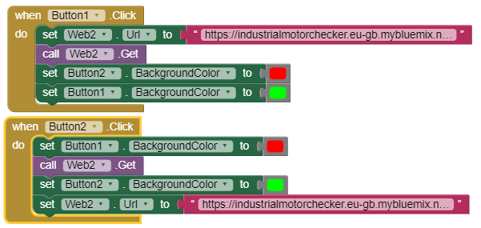

The Button colors mentioned in the block are activated along with the msg. payload when they are clicked.

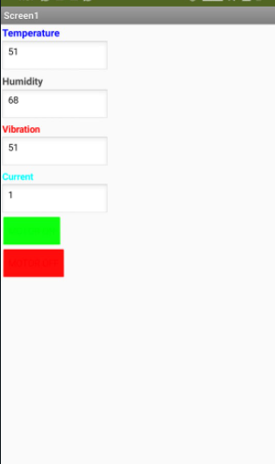

Chapter 4: Experimental Investigation



As it can be seen in the image above, the sensor values are successfully published.





The dashboard created with the help of node red can be seen above.



The mobile app created with the MIT app is shown above with the sensor values displayed and the buttons for the motor functions can also be seen.

ADVANTAGES

1. Data: *The data collected can be stored in the cloud platform and same can be accessed through the web page. And also timely alerts will be received for any violation in desired limits of parameters under monitoring, So that immediate action can be taken to avoid unwanted downtime of the motor that saves time and money.*

2. Tracking: *continuous monitoring of the equipment*

3. Time: *receiving alerts when mishaps happen in real time* 4. AI/ML: *data availability for predictive maintenance*

DISADVANTAGES

1. This device can trigger a shutdown but does not automatically service the system. A technician is still required to physically come down and repair the situation.

2. Privacy/Security: Privacy is a big issue with IoT. All the data must be encrypted so that data about the motors in your company and their working

3. Safety: There is a chance that the software can be hacked and the company’s information misused. The possibilities are endless. The motors can be sabotaged and cause confusion in the system.

APPLICATIONS

* Industrial Motor Maintenance
* Smart Health Monitoring System
* Greenhouse Maintenance System
* Smart House Monitoring
* Smart Garbage Disposal System

CONCLUSION

Progression in IoT have drawn consideration of engineers around the world. People involved in IoT related research are cooperating to broaden the innovation for enormous scope and to profit the general public to the most beneficial level. In any case, enhancements are conceivable just in the event that we think about the different issues and weaknesses in the current specialized methodologies. In this overview article, we introduced a few issues and difficulties that IoT designer must consider to build up an improved model. Likewise, significant application of IoT is additionally talked about where IoT engineers and scientists are occupied. As IoT isn't just offering types of assistance yet additionally creates a great amount of information. Henceforth, the significance of information examination is additionally talked about which can give precise choices that could be used to build up an improved IoT framework.

FUTURE SCOPE

This paper aims at developing the Predictive Industrial Motor Maintenance with an objective of automating the Industrial Motor system which provide information of the proper working of the motors. It can be further optimized by getting actuators to fix the motor by analyzing what is wrong with the motor as well. As human intervention is still required to diagnose the motor.